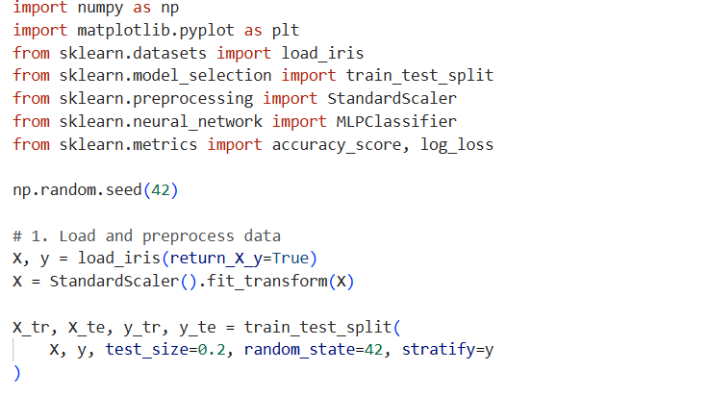
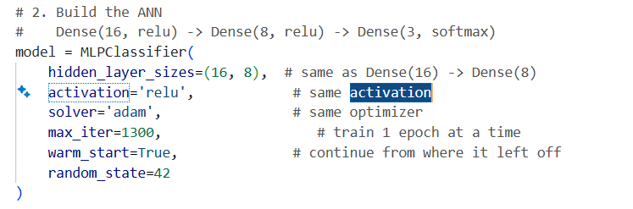

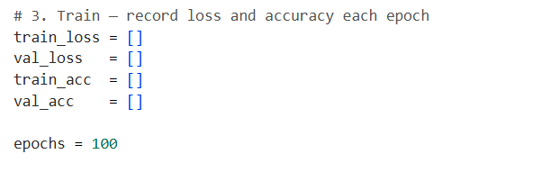

epochs = 100

print("Training...\n")
for epoch in range(epochs):
model.fit(X_tr, y_tr)

# training loss and accuracy
tr_pred_proba = model.predict_proba(X_tr)
te_pred_proba = model.predict_proba(X_te)

tl = log_loss(y_tr, tr_pred_proba)
vl = log_loss(y_te, te_pred_proba)
ta = accuracy_score(y_tr, model.predict(X_tr))
va = accuracy_score(y_te, model.predict(X_te))

train_loss.append(tl)
val_loss.append(vl)
train_acc.append(ta)
val_acc.append(va)

# print every 10 epochs like tensorflow verbose=1
if (epoch + 1) % 1 == 0:
print(f"Epoch {epoch+1:3d}/100 "
f"loss: {tl:.4f} acc: {ta:.4f} "
f"val_loss: {vl:.4f} val_acc: {va:.4f}")

# 4. Visualize loss and accuracy — same as tensorflow version
fig, (ax1, ax2) = plt.subplots(1, 2, figsize=(12, 5))

ax1.plot(train_loss, label='Training loss', color='blue')
ax1.plot(val_loss, label='Validation loss', color='orange')
ax1.set_title('Loss over Epochs')
ax1.set_xlabel('Epoch')
ax1.set_ylabel('Loss')
ax1.legend()

ax2.plot(train_acc, label='Training accuracy', color='blue')
ax2.plot(val_acc, label='Validation accuracy', color='orange')
ax2.set_title('Accuracy over Epochs')
ax2.set_xlabel('Epoch')
ax2.set_ylabel('Accuracy')
ax2.legend()

plt.tight_layout()
plt.savefig('ann_history.png')
plt.show()

# 5. Evaluate — same as model.evaluate()
final_loss = log_loss(y_te, model.predict_proba(X_te))
final_acc = accuracy_score(y_te, model.predict(X_te))
print(f'\nTest loss: {final_loss:.4f} | Test accuracy: {final_acc:.4f}')

